CIDA Onboarding Tasks and Troubleshooting

1. Claim CU account and activate email (Thuy sends out your employee ID to be able to do this)
2. CIDA Team Meeting invites – Theresa will send this
3. Get added to CIDA Team in Teams – Theresa will send this
4. Fill out your direct deposit and W-4 info in [UCDAccess](https://login.ucdenver.edu/) (Paycheck section)
5. Fill out your I-9 form (Thuy sends through HireRight) and send a copy of your passport/ID to Thuy
6. Set up MyLeave account – Thuy will go over this
7. Personal Drive / H Drive
   1. For help: contact David Pierce [support@medschool.zendesk.com](mailto:support@medschool.zendesk.com)
   2. Need to be on the VPN
   3. This one will map to \\data.ucdenver.pvt\home\username
   4. If you are not on a CU owned machine, here’s how David helped me sign in:
      1. Open "File Explorer"
      2. Select "This PC" on the left hand side of the new window
      3. Select "Computer" (Across the top of the window just to the right of File)
      4. Click on the button “Map Network Drive”
      5. Select an unused drive letter from the drop down menu in the “Drive:” area
      6. In the “Folder:” area enter in the drive path (in this case \\data.ucdenver.pvt\home\username)
      7. Make sure “Reconnect at logon” and “Connect using different credentials” are both checked
      8. Click "Finish"
      9. When asked to provide your login credentials, use university\username as the username.
8. Shared Drive/ P Drive
   1. You need to have Theresa request that you get access
   2. First need to be on the VPN – [download GlobalProtect here](https://www.ucdenver.edu/offices/office-of-information-technology/software/how-do-i-use/vpn-and-remote-access)
   3. Go to "This PC" (or Mac equivalent) → Map Drive →set drive to "P" →enter: \\ucdenver.pvt\sph →finish
   4. Theresa and Melissa need to request access for you to get to the Branches and Projects folders
9. Insurance – choose within first 30 days
   1. Health – also can register for [Colorado MOVE program](https://www.becolorado.org/program/be-colorado-move/) once you’ve been enrolled in a health plan
   2. Dental
   3. Disability
   4. Life
10. Trainings
    1. New Employee Orientation – you will get an email about this and it takes a few hours
    2. [Benefits Orientation](https://www.cu.edu/employee-services/benefits-wellness/PBO/new-employee)
    3. CU Anschutz trainings – go to SkillSoft in [UCDAccess](https://login.ucdenver.edu/), click on “CU Denver | Anschutz”, then search for these titles in the search bar
       1. CU: Information Security and Privacy Awareness
       2. CU: Information Security for IT Service Providers
       3. CU: Discrimination and Sexual Misconduct – CU Denver | Anschutz
       4. CU: HIPAA Regulations
    4. [CITI](https://about.citiprogram.org/en/homepage/)
       1. Sign in if you have an account or register for an account
       2. Set your affiliation to University of Colorado Denver
       3. Type of human subjects research – select biomedical investigator
       4. HIPAA – Select “CITI Health Information Privacy and Security (HIPS) for Clinical Investigators”
       5. The most common good clinical practice (GCP) option is “Group 4: ICH/GCP – meets NIH requirements”
       6. [If you have any questions or need additional information](http://www.ucdenver.edu/research/comirb/training/Pages/Training.aspx)
    5. [REDCap](https://redcapinfo.ucdenver.edu/redcap-tutorials.html)
11. Smartsheet
    1. You need to [create an unlicensed user account](https://medschool.zendesk.com/hc/en-us/articles/1500003375301-Creating-an-Unlicensed-user-account)
    2. Someone will contact you directly from Smartsheet and you have to respond “yes” to their email
    3. This is where your timesheet lives
    4. This is also where the SOW intake form lives
12. Calendly – Melissa will send sign-in information and directions on how to set up meeting times if that’s appropriate
13. [Eureka](https://www.healthdatacompass.org/cloud-analytics-infrastructure)
    1. Go to <https://www.healthdatacompass.org/cloud-analytics-infrastructure> and scroll down to “Getting Started”
    2. Follow the directions to get a new Compass User Account
    3. To get a new Eureka instance, email Madelyne Hull [MADELYNE.HULL@CUANSCHUTZ.EDU](mailto:MADELYNE.HULL@CUANSCHUTZ.EDU) and ask for an App-VM instance
    4. Specs for n1-highmem-8 (works well with up to 35 million records)
       1. 8 CPUS
       2. 52GB RAM
       3. 500 GB storage
    5. If you are working with OMOP you’ll need more storage!! More like 75 million
    6. Getting into your virtual machine
       1. Turn on the VPN
       2. Open a new Chrome window and sign in using your HDC login
       3. Go to the link for your virtual machine that Madelyne provides (I recommend saving this link to the bookmarks bar)
       4. It’s likely that you’ll get an error message. If so, wait 30 seconds, open a new tab and try again
       5. Sign into the machine with your HDC credentials
       6. From here, you can follow the [directions on the HDC website](https://www.healthdatacompass.org/cloud-analytics-infrastructure/using-eureka-app-vm)
       7. Note you cannot copy and paste between your local computer & within the virtual environment.
    7. Downloading R packages
       1. Connect HDC to your instance (should only need to do this once)
          1. Open terminal
          2. Type: gcloud auth login
          3. Type “Y” to continue
          4. Copy and paste the link into a web browser or right click on the link and select open. Follow the directions to log into your HDC account and accept the terms. Copy the key that it gives you at the end.
          5. Paste key into the terminal
       2. Check HDC is connected to your instance (do this in the future when you sign in)
          1. Click on “Activities” in the upper left corner and search for “terminal” (or open Rstudio and navigate to the terminal tab)
          2. Type and enter: gcloud auth list
          3. If there is an * in the ACTIVE column of the output, then you are connected
          4. If not, redo step (i) above
       3. Get CRAN running
          1. Click on “Activities” in the upper left corner and search for “Eureka limited internet app”
          2. Click on CRAN Bioconductor – this will take about 10 minutes to boot up and then you’ll want to click every 20 minutes or so to keep it open
          3. If you type “curl https://cloud.r-project.org | head” into the terminal and get HTML code as a reply, then you are connected
       4. If you need to install a package from another source like Github, follow the steps 1 and 2 from part (iii) above selecting the source you need access to. You may select more than one source at a time and it does not hurt to occasionally re-select sources to ensure access to CRAN/Github/other sources does not time out.
       5. If you can’t install R packages, you might need to set up a new directory
          1. Make sure RStudio is closed
          2. In the terminal, enter these two lines:
             1. install -m0700 -d “$HOME/tmp”
             2. printf “TMPDIR = %s/tmp\n” “$HOME” > “$HOME/.Renviron”
          3. Reopen R and type “tempdir()” in the console
          4. The response should read: “home/username/tmp/RtmpXXXX” with your username and various letters/numbers in place of XXXX
       6. If you’re still having problems regarding functionality of Eureka/HDC virtual machine contact John Finigan ([JOHN.FINIGAN@CUANSCHUTZ.EDU](mailto:JOHN.FINIGAN@CUANSCHUTZ.EDU))
14. Getting a badge
    1. Let Melissa know you are coming into the office so she can request one for you.
    2. When you get an email from the Badging Office, schedule an appointment to get your badge 303-724-0399.
    3. You can either call the badging office or use the call button to the right of the door, ask for them to connect you to the badging office, and then ask for someone to come let you in. The process of getting a badge only took a few minutes.
15. Getting keys
    1. Let Melissa know you are coming into the office so she can request keys from the Lock Shop.
    2. When you get an email from them, call and make an appointment (303-724-0688). Be aware that they have very specific hours.
    3. Lock Shop is about a 10-minute walk from Fitzsimons. The entrance is at the corner of the L. Call the same number and someone should come get you. Picking up the key is also super quick.

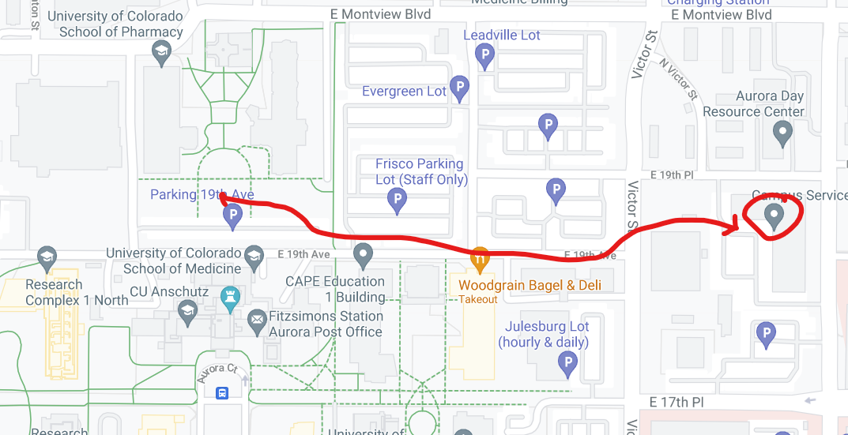

1. Getting to the office
   1. There is parking on the north side of the Fitzsimons building.
   2. Use your badge to enter the building and go to the elevators in the center of the building (you’ll see the freight elevator first if you come in from the north side, walk around to get to the other elevators)
   3. Take the center elevators to the 4th floor. Take a right when you get off and then walk through a set of wooden double doors. Go all the way back until you come to a glass set of doors that will say "Biostatistics" on it. You will need to badge in on the black box for the door to open.
   4. Ask Melissa for specific directions to your desk/office. Then thank her for answering all your questions.